**-Recursion**

When a function calls inteself

Until a specified condition is met.

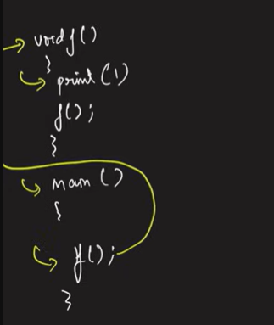 Output

1 to stack overflow

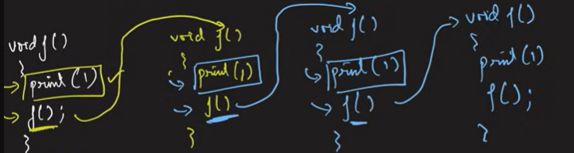

Infinite Recursion

Memory has an capacity,,due to not completing function these ‘

cause segmentation fault called Stack Overflow

**Example**

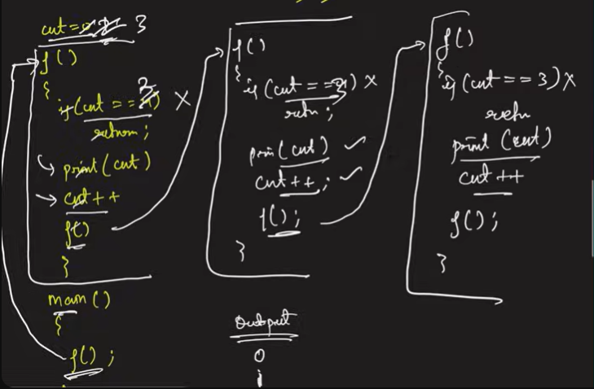**To stopping the function used base condition**

Base Condition or Specified Condition was

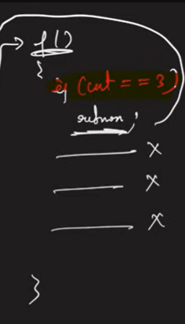

If ( cnt == 3 )

Return 0;

else print cnt ;

Call function again f();

**Recursion Tree -** function calling and function returning representation called as recursion tree

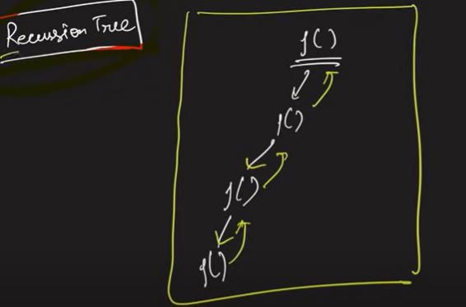

* Recursion
* Base case
* Stack Overflow | stack Space
* Recursion Tree

**Basic Recursion Problems**

1. Print Name N Times

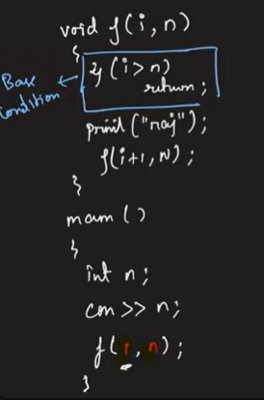

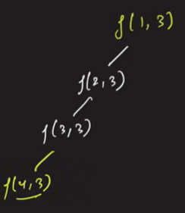

Recursion Tree

TC – O(n)

SC - same

1. Print 1 to N linearly Print N to 1 Linearly

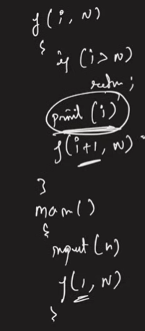

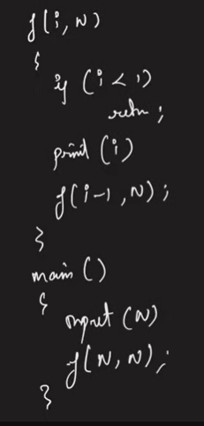

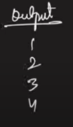

**Backtracking   
Print linearly 1 to N using backtracking**

